Kidnap (Text Adventure Game)

**Story: -**

In this game, we will control a person who is being kidnaped by someone and we will try to escape him from there by making some choices through button presses below given is the state diagram which define the entire game it’s not a master piece but if you follow the steps I hope that will make a better game developer…

**State Diagram: -**

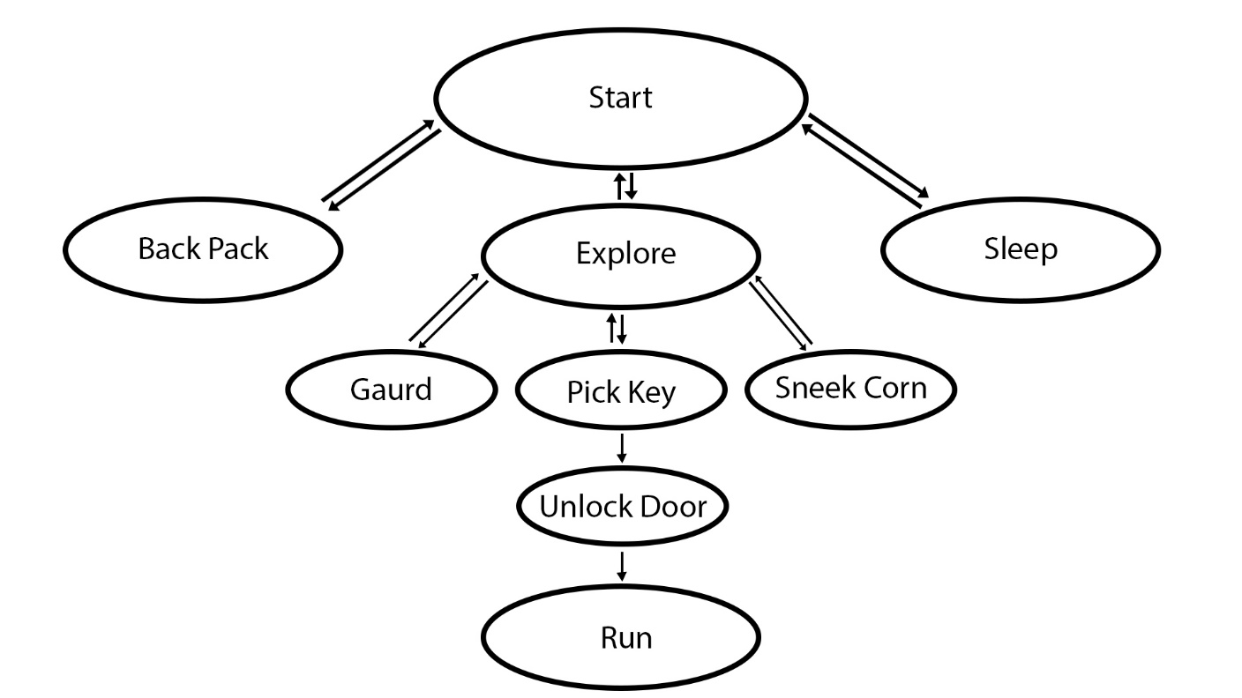

According to this diagram the when the game starts the player can explore the room also the player can go to sleep and the player can also check it back pack…